A000-Eur**-**Russia**-**Kostyonkovsky-Avdeevskaya Culture-Mammoth-Granite-Upper Paleolithic-22,000 BP

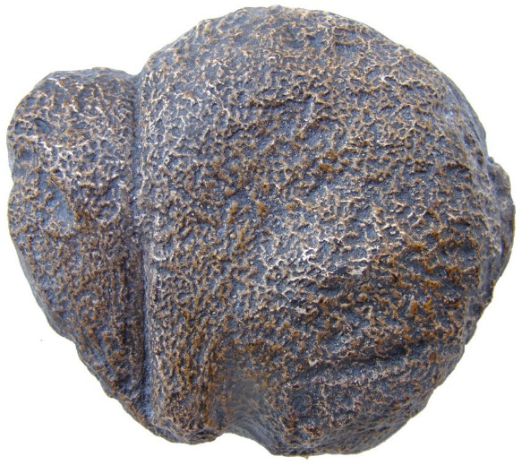

Fig. 1. Russia**-**Kostyonkovsky-Avdeevskaya Culture-Upper Paleolithic-22,000 BP-Mammoth Sculpture-Granite

Case No. 1

**Formal Label:** Russia**-**Kostyonkovsky-Avdeevskaya Culture-Upper Paleolithic-22,000 BP-Mammoth Sculpture-Granite

**Display Description:** TheKostyonkovsky-Avdeevskaya Culture in the valley of the Don, Russia, dated to 22,000 BP-19,000 BP, was formed by the coalescence of tribes from Moravia along the river valleys of the Vistula, Pripyat and Desna to the Don river valley as they followed Pleistocene animals, including mammoths, along the edge of the glacial advance during the Last Glacial Maximum (LGM). This cobble may have been found in a glacial outwash and sculptured in the form of a mammoth as an amulet to invoke the spirit of the mammoth.

**Accession Number:**

**LC Classification:** GN772.2.P4

**Date or Time Horizon:** 22,000 BP-19,000 BP

**Geographical Area:** valley of the Don

**Map and GPS Coordinates:** 62°00′47″N36°03′05″E; 62.0132 36.0516.

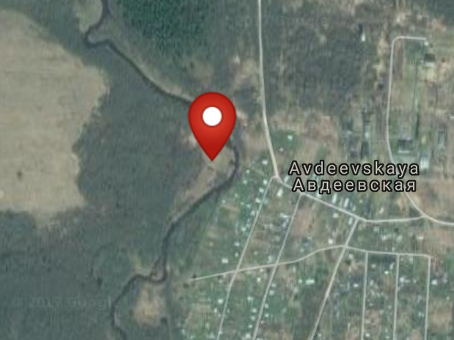 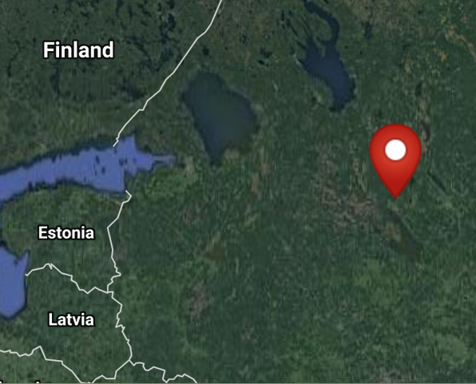

**Figs. 2-3. Maps of** Avdeevskay from http://latitude.to/img/latitude-logo.svg.

**Cultural Affiliation:** Upper Paleolithic Kostyonkovsky-Avdeevskaya Culture of the Kostionkų-Avdejeva Complex

**Medium:** original, granite.

**Dimensions:   
Weight:**

**Provenance: museum replica in resin**

**Condition: museum replica in resin**

**Discussion:**

TheKostyonkovsky-Avdeevskaya culture (Костёнковско-авдеевская культура) Culture (of the Kostionkų-Avdejeva Complex) in the valley of the Don is dated to 22,000 BP-19,000 BP and was formed as a result of the coalescence of tribes from Moravia along the valleys of the Vistula, Pripyat and Desna to the Don as they pursued animals during the advance of the glaciers during the LGM. It is part of the third stage in the Aurignac-Perigordian Complex of cultures of the Upper Paleolithic of Central and Western Europe, united by a number of common traits that exhibit a new symbolic aesthetic (including Acheulian lithics, textiles, and Venus figurines) and a new concept of communal spirituality signaled by the ritualized burials of infants, adolescents and adults (Einwögerer 2006).

This schematized mammoth sculpture was sculpted by Cro-Magnon (*Homo sapiens sapiens*) probably from a glacial cobble during the LGM. This globular cobble is divided into two volumes, one which is a bulbous body with front and hind legs subtly indicated and the other which is the angular head and trunk. Only the left side still retains these hints of the mammoth’s shape, while the right side has been highly eroded.

**References:**

Einwögerer, Thomas, Herwig Friesinger, Marc Händel, Christine Neugebauer-Maresch, Ulrich Simon, Maria Teschler-Nicola. 2006. “Upper Palaeolithic infant burials,” *Nature*, 444: 285.

Svoboda, Jiří A. and Ofer Bar-Yosef. 2003. *Stránská skála: origins of the Upper Paleolithic in the Brno Basin, Moravia, Czech Republic.* Cambridge, MA: Peabody Museum of Archaeology and Ethnology, Harvard University.